**Daily Scrum or Standup Meeting**

Team name: 5th Element

Scrum Master: Leonardo Craven

Date: November 5, 2021

| **Team Member** | **What did you do since the last scrum?** | **What do you plan to do before the next scrum?** | **What obstacles do you have?** |
| --- | --- | --- | --- |
| Leo | Nothing | Finish edit drink menu page | None |
| Gavin | Work on current orders page | Finish current orders page | None |
| Andrew | Brainstorm ideas for visual improvement | Brainstorm visual improvement ideas  Work on order drinks page | Homework (done by Monday) |
| Brock | Work on support for money accounts | Work on support for user accounts (done by Monday) | None |

# Burndown

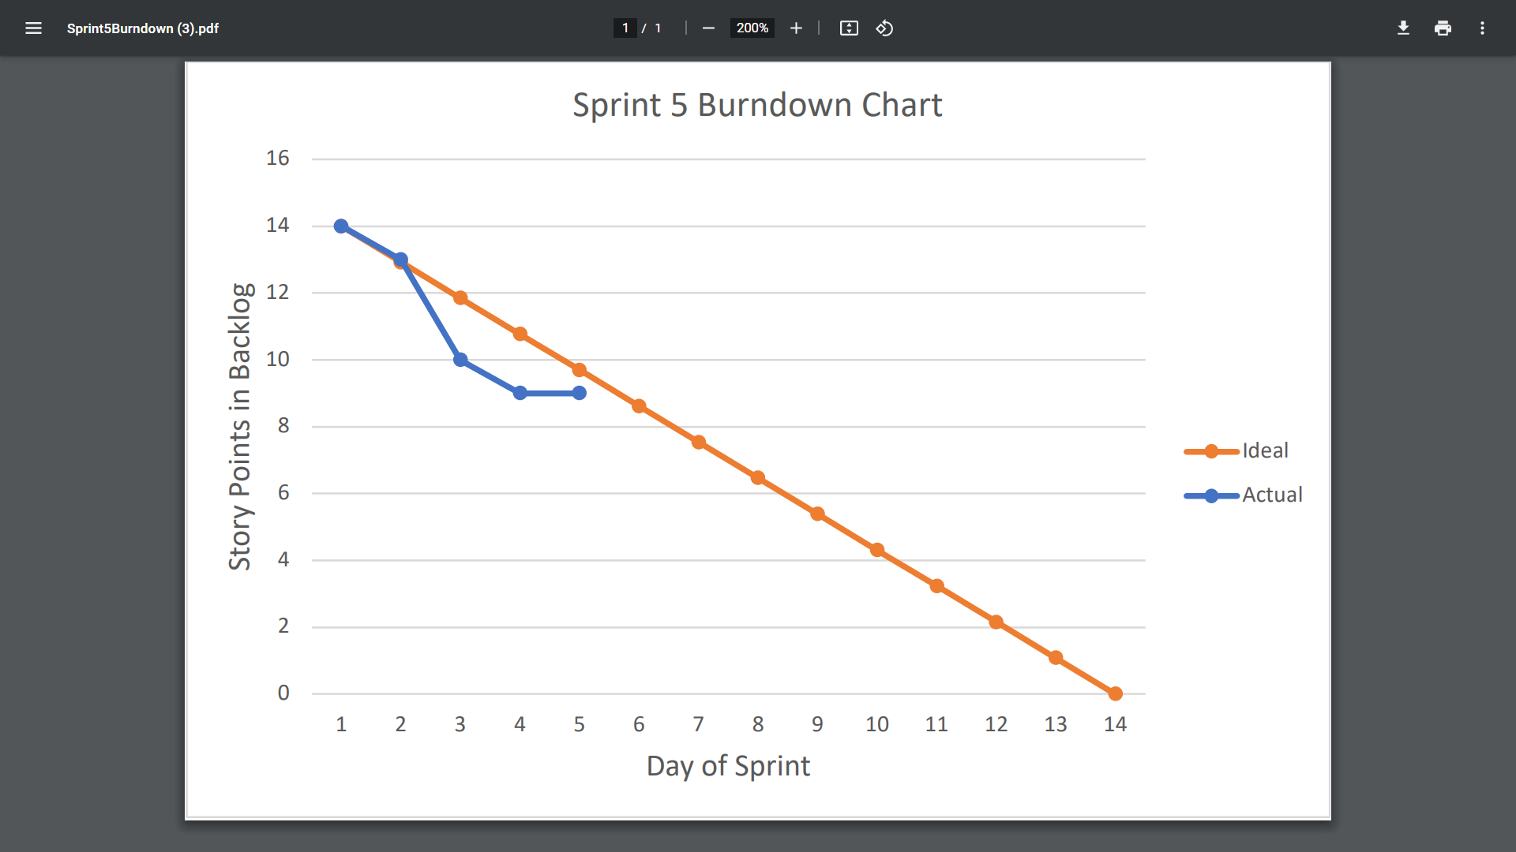

# Screenshot of you project board

